Chapter 1
Create a bar chart
In this exercise, we'll be using bar charts, one of the most fundamental and powerful visualization tools, to explore and analyze data. Bar Charts are particularly effective when you want to compare quantities across different categories. In this case, we'll focus on visualizing the fare amounts for NYC taxi trips across different hours of the day.
Let's get started and discover what interesting patterns and insights you can reveal!
- In the SQL Editor, write and execute the following query.
- Create a new Bar visualization.
- Set pickup_hour as the X column and select the average of fare_amount as the Y column.
- Rename the visualization to "Avg Fare vs. Hour of the day", and save it.
- Which hour of the day has the highest average fare amount? R: 5AM

SELECT *,
hour(tpep_pickup_datetime) as pickup_hour,
month(tpep_pickup_datetime) as month
FROM `samples`.`nyctaxi`.`trips`

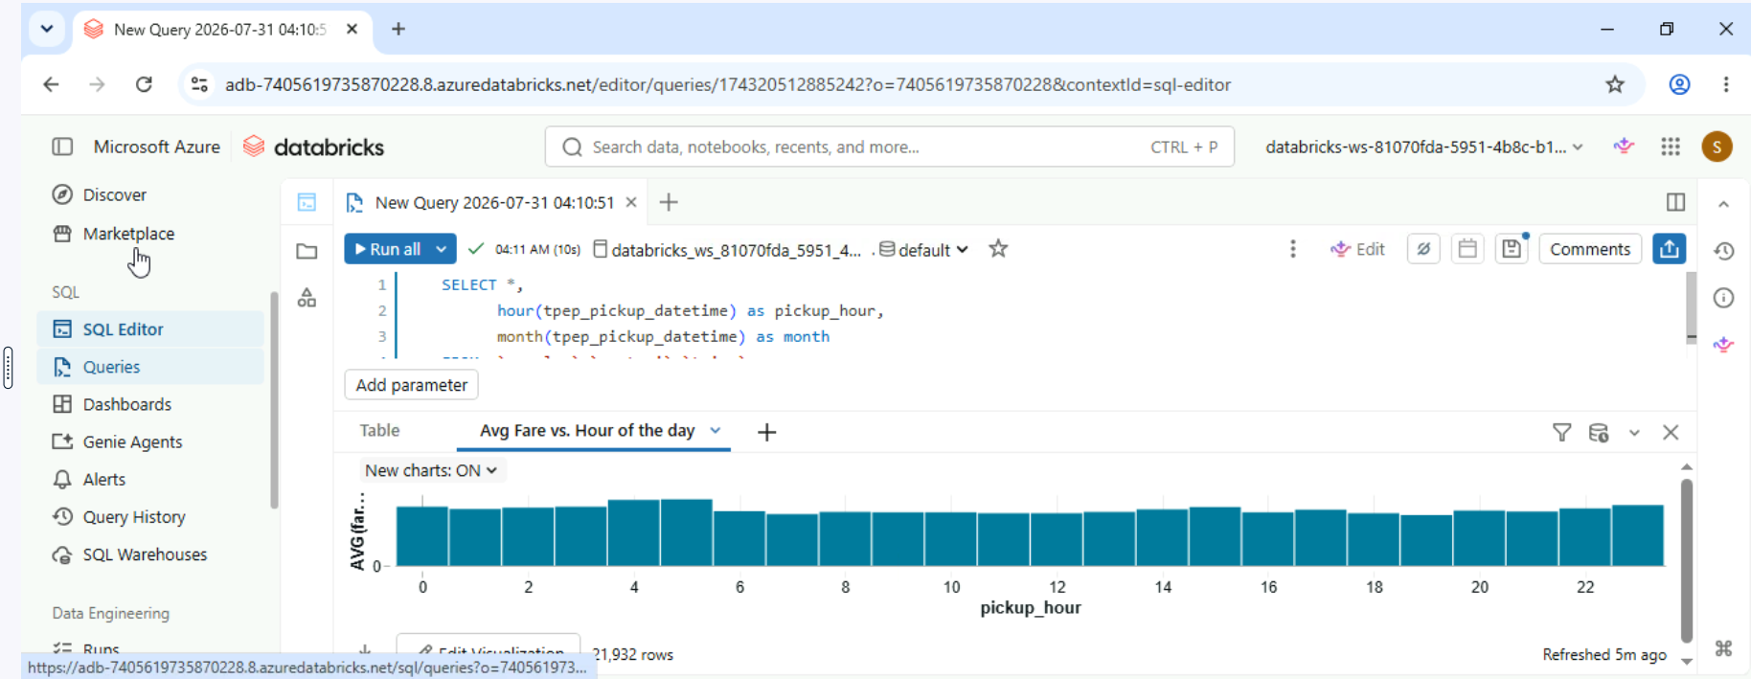

Create a Line Chart
In this exercise, we'll continue our exploration of NYC taxi trip fares by using line charts, an excellent tool for analyzing trends over time. Line charts allow you to track changes in data across continuous intervals — in this case, the different hours of the day. Your challenge is to determine which hour of the day has the lowest standard deviation in fare amounts. This insight can help identify periods with more stable fare pricing, offering clues about consistent demand or pricing strategies.
- In the SQL Editor, write and execute the following query.
- Create a new Line visualization.
- Set pickup_hour as the X column and select the standard deviation of fare_amount as the Y column.
- Rename the visualization to "Std Fare vs. Hour of the day", and save it.
- Which hour of the day has the lowest standard deviation of the fare amount? R: 7PM
SELECT *,
hour(tpep_pickup_datetime) as pickup_hour,
month(tpep_pickup_datetime) as month
FROM `samples`.`nyctaxi`.`trips`
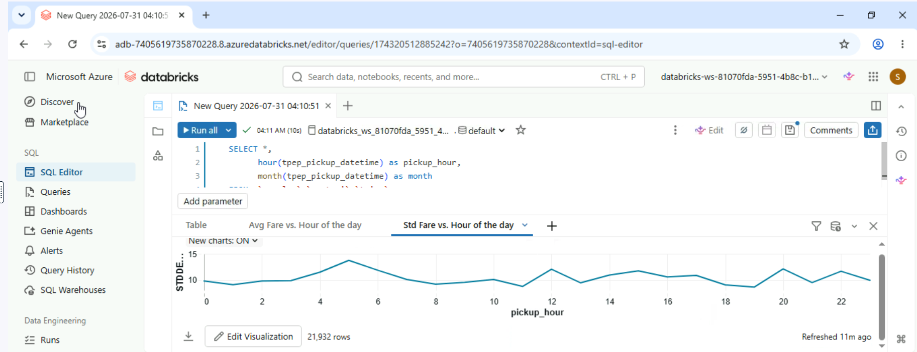

Create a Combo Chart
Combo charts combine line and bar charts to provide a comprehensive view of data, allowing you to observe both trends over time and proportional relationships simultaneously. In this exercise, you'll create a combo chart to compare multiple data series, such as the total fare amount and total trip count by hour.
Creating this combo chart will help you uncover deeper insights into how different aspects of the data relate to each other. Explore the chart to see how these metrics align and reveal valuable patterns that could inform your analysis.

- In the SQL Editor, write and execute the following query.
- Create a new Combo visualization.

- Set pickup_hour as the X column.
- Select sum of trip_distance as the first Y column.
- Select sum of fare_amount as the second Y column.
- Rename the visualization to "Comparison by Hour", and save it.
- Which hour of the day has both the lowest total fare amount and the lowest total trip distance? R:5AM
SELECT *,
hour(tpep_pickup_datetime) as pickup_hour,
month(tpep_pickup_datetime) as month
FROM `samples`.`nyctaxi`.`trips`
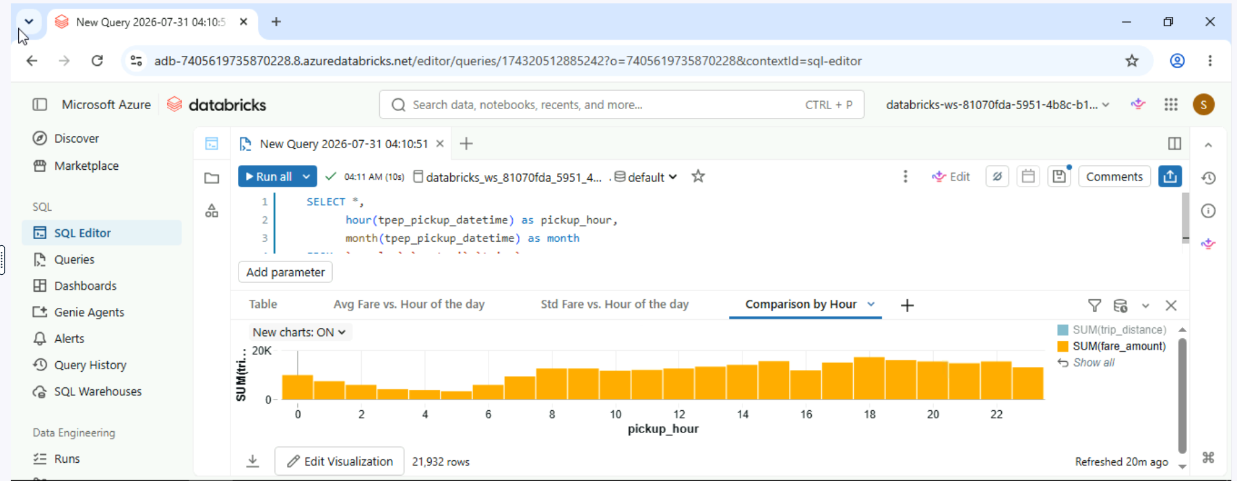

Create a Choropleth Map
In this exercise, we'll be exploring choropleth maps, a valuable visualization tool for representing data across different geographical areas. We will visualize sales distribution across various countries using the dataset provided.
Imagine you're a data analyst for a global retail company. How might sales figures vary from one country to another? Are there regions where sales are particularly high, or areas where they fall short?
Let's get started and uncover the geographical patterns and opportunities revealed by your choropleth map!
- In the SQL Editor, choose the Catalog as the one starting with "databricks".This is to the right of the Run button.
- Write and execute the following query.
- Create a new visualization as a Map (Choropleth).

- Set Countries as the Map.
- Select Country as the Geographic column and Full name as the Geographic type.
- Select TotalPrice as the Value column.
- Rename the visualization to "Total Sales vs Country", and save it.
- Which country has the highest total sales? R: United Kindom
SELECT
Country,
Latitude,
Longitude,
COUNT(DISTINCT CustomerID) AS UniqueCustomerCount,
SUM(Quantity * UnitPrice) AS TotalPrice
FROM
online_retail
GROUP BY
Country,
Latitude,
Longitude
ORDER BY
Country;
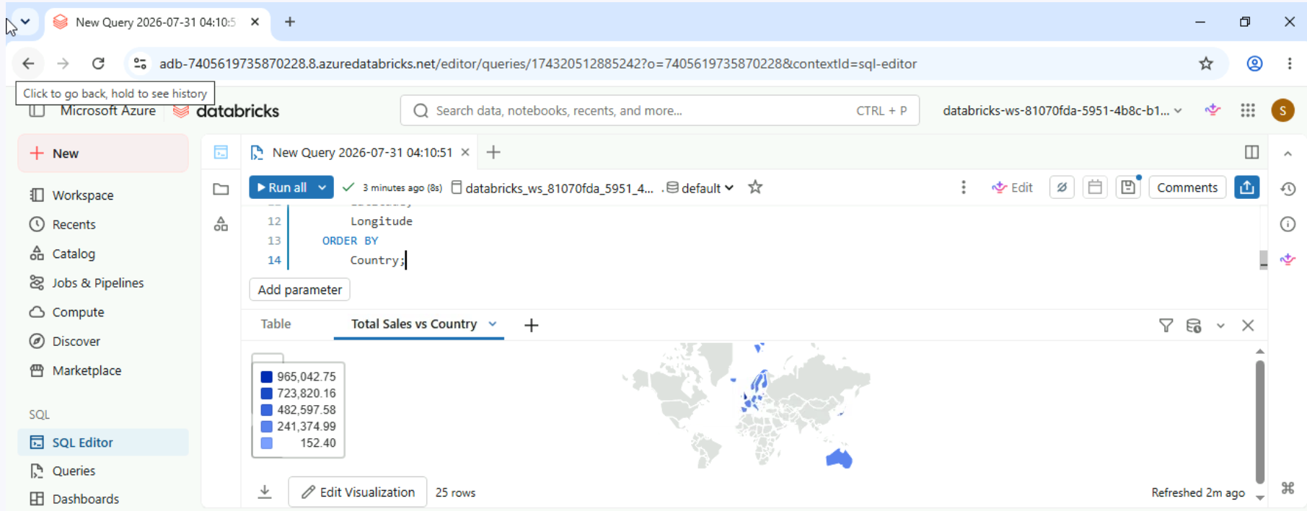

Create a Marker Map
In this exercise, you'll be working with marker maps to analyze customer distribution. Our goal is to explore how marker maps can visually represent data across different geographic locations.
For this exercise, you need to determine the number of customers specifically in France based on the map's visual indicators.
- In the SQL Editor, choose the Catalog as the one starting with "databricks".This is to the right of the Run button. Write and execute the following query.
- Create a new visualization as a Map(Markers).

- Set Latitude as Latitude column.
- Set Longitude as Longitude column.
- Select UniqueCustomerCount as the Group by.
- Rename the visualization to "Count of Customers vs Country", and save it.
- How many customers are there in France? R:30

SELECT
Country,
Latitude,
Longitude,
COUNT(DISTINCT CustomerID) AS UniqueCustomerCount,
SUM(Quantity * UnitPrice) AS TotalPrice
FROM
online_retail
GROUP BY
Country,
Latitude,
Longitude
ORDER BY
Country;

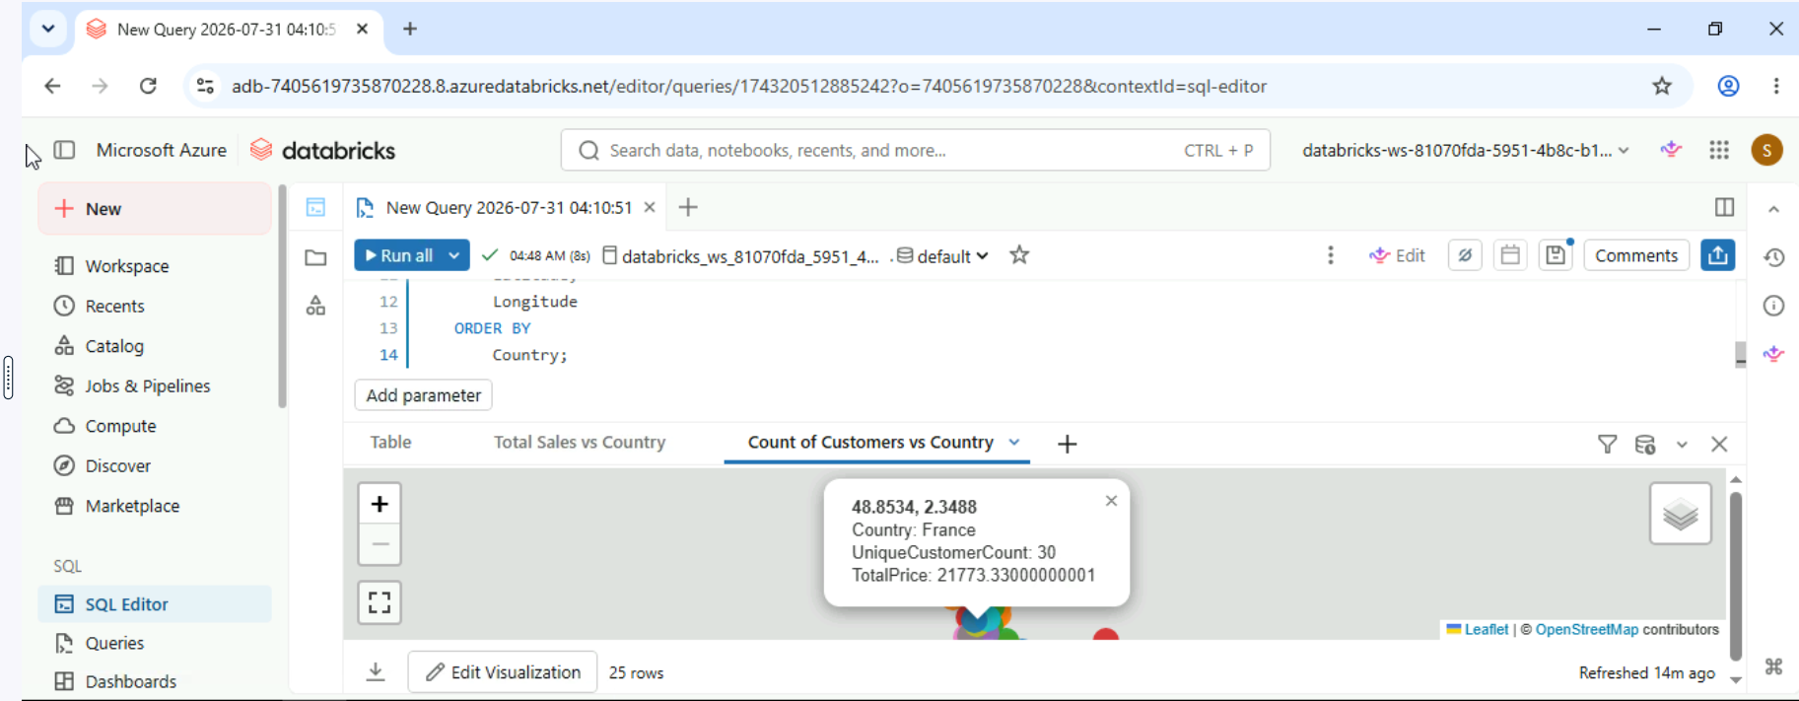

Find the most profitable day
In this exercise, you'll create a new visualization to analyze NYC taxi trips and uncover valuable insights. Building on your expertise with visualizations in the SQL Editor in Databricks, your task is to determine which day of the week generates the highest total fare.
As you work through this challenge, consider how effective visual design can highlight key data points and make comparisons easier. Let's get started.
- In the SQL Editor, write and execute the following query.
- Create a Bar Plot that includes information on the days of the week and the total fare amount.
- Rename the visualization to "Fare vs Day of Week", and save it.
- Which day of the week has the highest total fare amount? R:

SELECT
T.tpep_pickup_datetime,
T.tpep_dropoff_datetime,
T.fare_amount,
T.pickup_zip,
T.dropoff_zip,
T.trip_distance,
T.weekday,
CASE
WHEN T.weekday = 1 THEN 'Sunday'
WHEN T.weekday = 2 THEN 'Monday'
WHEN T.weekday = 3 THEN 'Tuesday'
WHEN T.weekday = 4 THEN 'Wednesday'
WHEN T.weekday = 5 THEN 'Thursday'
WHEN T.weekday = 6 THEN 'Friday'
WHEN T.weekday = 7 THEN 'Saturday'
ELSE 'N/A'
END AS day_of_week
FROM
(
SELECT
dayofweek(tpep_pickup_datetime) as weekday,
*
FROM
`samples`.`nyctaxi`.`trips`
WHERE
trip_distance > 0
AND trip_distance < 10
AND fare_amount > 0
AND fare_amount < 50
) T
ORDER BY
T.weekday
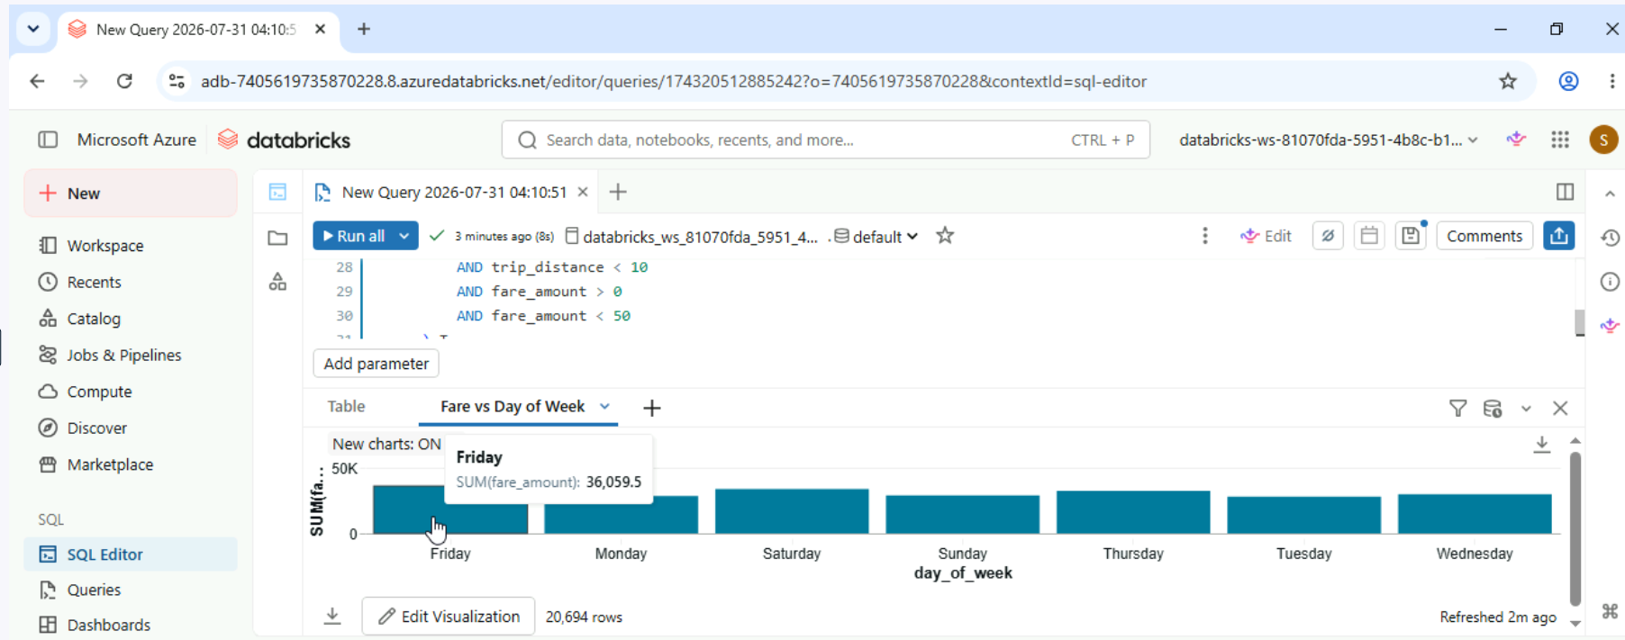

Chapter 2
Configuring axes and labels
In this exercise, you'll improve a Bar Chart by adjusting the axis titles and labels. You're analyzing total fare amounts for a taxi company over the past two months.
With just two months of data, it's still essential to clearly label your chart to convey the total fares accurately. How can changing the axis titles and labels enhance understanding of the fare amounts for each month?
Focus on making your chart easy to read and interpret. Properly configured labels will help clearly present the total fares.

- In the SQL Editor, write and execute the following query. Remember to untick LIMIT 1000 in the Run button to ensure all data is loaded before executing the query.
- Create a new Bar visualization. Follow the instructions in the next steps before saving.
- Select the sum of fare_amount as the Y column and choose month as the Group by.
- Change the Labels of the Series to "Jan" and "Feb", respectively. Change the name of the Y axis to "Total Fare Amount".
- Add Data labels to the bars.
- Name the visualization as "Sum of Fare by Month" and save it.
What is the total fare amount for February? Provide your answer using the same format as the labels. R: 136,671.67

SELECT
*,
hour(tpep_pickup_datetime) as pickup_hour,
month(tpep_pickup_datetime) as month
FROM
`samples`.`nyctaxi`.`trips`

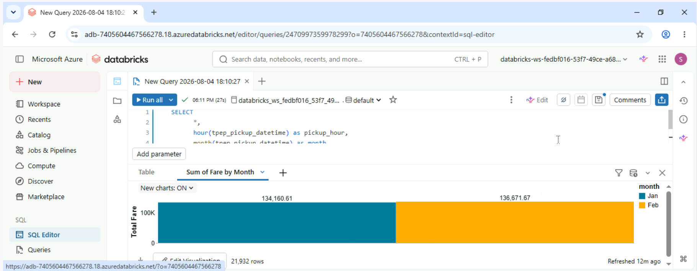

Applying formatting
In this exercise, you'll enhance a Line Chart by applying different color schemes and formatting numeric types in your data labels. You have total fare amounts tracked by hour, with separate lines for each of the two months.
With fare data visualized hourly for each month, using distinct colors helps differentiate between the trends for each month. Additionally, formatting numeric types in data labels will make the values clearer and more readable.
- In the SQL Editor, write and execute the following query. Remember to untick LIMIT 1000 in the Run button to ensure all data is loaded before executing the query.
- Create a new Line visualization.
- Set pickup_hour as the X column. Set the sum of fare_amount as the Y column. Set choose month as the Group by.
- Update the color of the February (month 2) line to red. Change the name of the Y axis to "Total Fare Amount".
- Add Data labels to the bars. Change the label format to display only numbers in the thousands and above using "0a"
- Name the visualization as "Total Fare by Hour and Month" and save it.
What is the maximum value labelled on the red line?. R: 9k
SELECT
*,
hour(tpep_pickup_datetime) as pickup_hour,
month(tpep_pickup_datetime) as month
FROM
`samples`.`nyctaxi`.`trips`

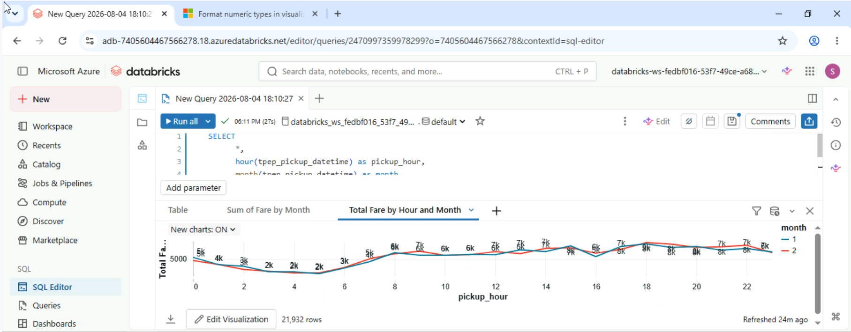

Configuring a Pie Chart
In this exercise, you'll use a Pie Chart to analyze the distribution of total fares by hour of the day. Pie Charts are great for showing how each segment contributes to the whole, helping you understand the relative importance of fare amounts at different times.
Imagine you're a data analyst for a taxi company. Your goal is to uncover how fares vary throughout the day and identify any peak times or trends. As you create your Pie Chart, focus on how each hour’s fare contributes to the total. Customize the series labels for clarity and adjust the data label format to better display percentages.

- In the SQL Editor, write and execute the following query. Remember to untick LIMIT 1000 in the Run button to ensure all data is loaded before executing the query.
- Create a new Pie visualization.
- Set pickup_hour as the X column, and select the sum of fare_amount as the Y column
- Name the series as "Total Fare by Hour".
- Add Data labels to the bars and adjust the label format to show only one digit after the decimal point.
- Name the visualization as "Total Fare Distribution by Hour" and save it.

7 PM has the second highest value in the _Pie Chart_. What is the percentage of the total fare amount for this pickup hour? Provide your answer in the same format as the labels. R:5.9%

SELECT
*,
hour(tpep_pickup_datetime) as pickup_hour,
month(tpep_pickup_datetime) as month
FROM
`samples`.`nyctaxi`.`trips`

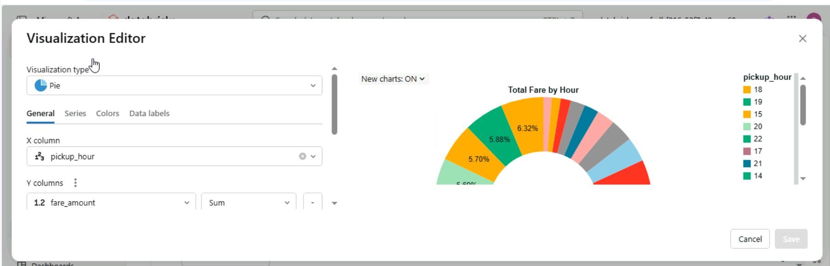

Create a Histogram
In this exercise, you'll work with a Histogram displaying trip counts based on distance ranges. You will adjust the number of bins to gain a more detailed view of the data.
Your task is to identify the number of trips within a specific distance range. This will help you practice interpreting detailed histogram data and verifying your findings using visualization tools.
By the end of this exercise, you should be able to accurately determine and interpret trip counts for different distance ranges, leveraging the detailed view provided by adjusting the number of bins.

- In the SQL Editor, write and execute the following query. Remember to untick LIMIT 1000 in the Run button to ensure all data is loaded before executing the query.
- Create a new Histogram visualization.
- Set trip_distance as the X column.
- Increase the number of bins to 50. This will divide the data into narrower ranges, providing a more granular view of the distribution.
- Change the name of the X axis to "Trip Distance (miles)". Change the name of the Y axis to "Count of Trips".
- Rename the visualization to "Histogram of Trip Distance", and save it.
The trip distance range of 1.836 to 2.448 miles has the third highest number of trips. What is the trip count for this distance range? R: 2,658

SELECT
*,
hour(tpep_pickup_datetime) as pickup_hour,
month(tpep_pickup_datetime) as month
FROM
`samples`.`nyctaxi`.`trips`

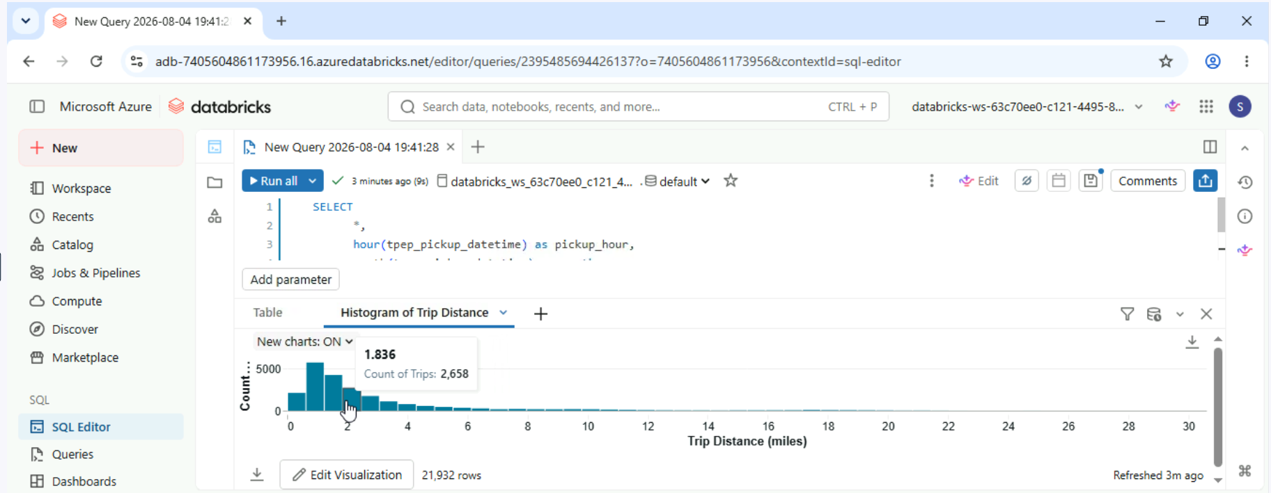

Evening trip counts: highlighting peak hours
In this exercise, you’ll create a Bar Chart to show the total number of trips for each hour starting from 5 PM.
To make the chart clearer and more informative, highlight the hour with the highest trip count by coloring that bar differently. This will help viewers quickly identify peak times and see how trips are distributed throughout the evening.
Effective visualizations reveal trends and tell a story about the data. By emphasizing key hours with strategic color use, viewers will better grasp patterns and insights from the evening trip counts, making the data more engaging and understandable.

- In the SQL Editor, write and execute the following query. Remember to untick LIMIT 1000 in the Run button to ensure all data is loaded before executing the query.
- Create a new Bar visualization.
- Set pickup_hour as the X column, select the count of * as the Y column, and choose pickup_hour as the Group by.
- Update the Scale or X axis to Categorical to ensure each hour is represented as a distinct category on the chart. Change the name of the Y axis to "Count of Trips".
- Set the color of the tallest bar to red and all other bars to blue. Add Data labels to the bars.
- Rename the visualization to "Evening Trip Count", and save it.
What is the trip count represented by the red bar? R:

SELECT
*,
hour(tpep_pickup_datetime) as pickup_hour,
month(tpep_pickup_datetime) as month
FROM
`samples`.`nyctaxi`.`trips`

WHERE
hour(tpep_pickup_datetime) >= 17

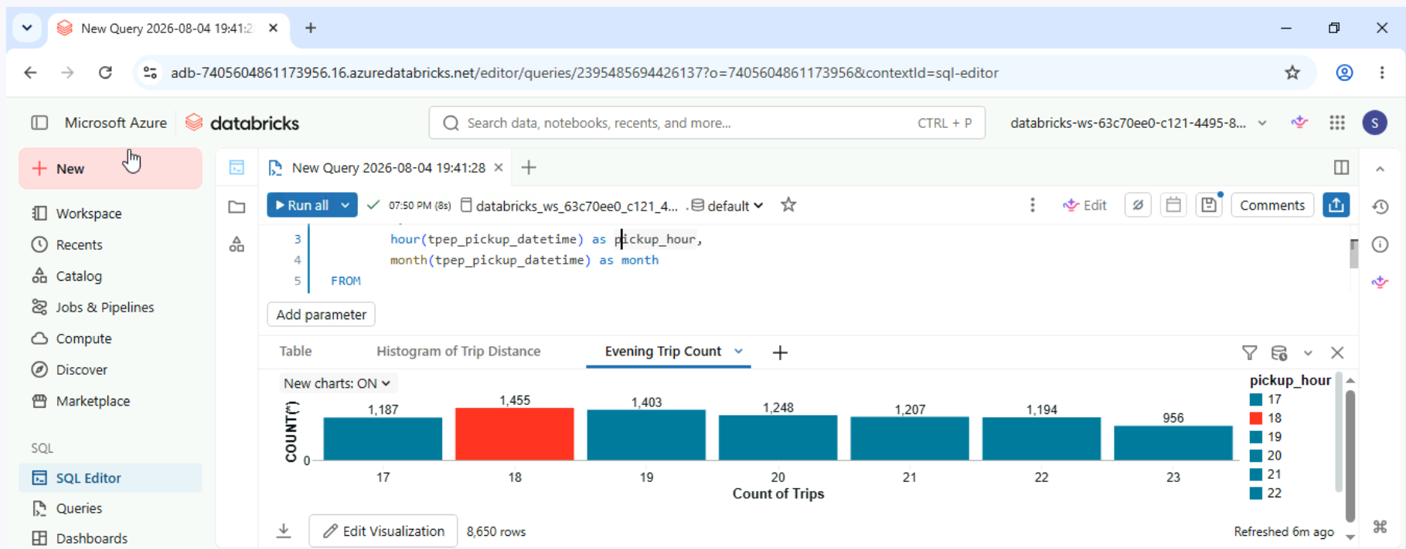

Customizing a summary table
In this exercise, you’ll create your first Customizable Tables on Databricks to analyze and present taxi trip data by day of the week. The table will display key metrics, including total fare amount, total trip distance, and average fare amount for each day of the week.

Your task is to customize the table to highlight important insights and make the data more accessible. This includes adjusting formatting options such as font format and color for readability, and organizing columns and rows to emphasize significant trends. Additionally, you will use sorting to reveal patterns.

By effectively customizing the table, you will enhance its clarity and focus, making it easier for viewers to understand daily patterns and make informed decisions based on the summarized metrics. This exercise will help you develop skills in presenting data in a way that aligns with storytelling and highlights key insights.

- In the SQL Editor, write and execute the following query. Remember to untick LIMIT 1000 in the Run button to ensure all data is loaded before executing the query.
- Create a Table visualization that includes all information from the raw output except the average_trip_distance.
- Format the numbers in the total_fare_amount and average_fare_amount columns to display with a dollar sign prefix in the table.
- Adjust the font color in the total_fare_amount column: use blue for the default color, and green for values exceeding 30000. This adjustment makes it easier for viewers to quickly identify and focus on different fare amounts, highlighting significant values and improving overall readability.
- Name the visualization as "Summary Table" and save it.
What is the highest total trip distance for the day of the week where the values in the `total_fare_amount` column are displayed in blue? R:

SELECT
CASE
WHEN dayofweek(tpep_pickup_datetime) = 1 THEN 'Sunday'
WHEN dayofweek(tpep_pickup_datetime) = 2 THEN 'Monday'
WHEN dayofweek(tpep_pickup_datetime) = 3 THEN 'Tuesday'
WHEN dayofweek(tpep_pickup_datetime) = 4 THEN 'Wednesday'
WHEN dayofweek(tpep_pickup_datetime) = 5 THEN 'Thursday'
WHEN dayofweek(tpep_pickup_datetime) = 6 THEN 'Friday'
WHEN dayofweek(tpep_pickup_datetime) = 7 THEN 'Saturday'
ELSE 'N/A'
END AS day_of_week,
SUM(fare_amount) AS total_fare_amount,
SUM(trip_distance) AS total_trip_distance,
AVG(fare_amount) AS average_fare_amount,
AVG(trip_distance) AS average_trip_distance
FROM
`samples`.`nyctaxi`.`trips`
WHERE
trip_distance > 0
AND trip_distance < 10
AND fare_amount > 0
AND fare_amount < 50
GROUP BY
day_of_week

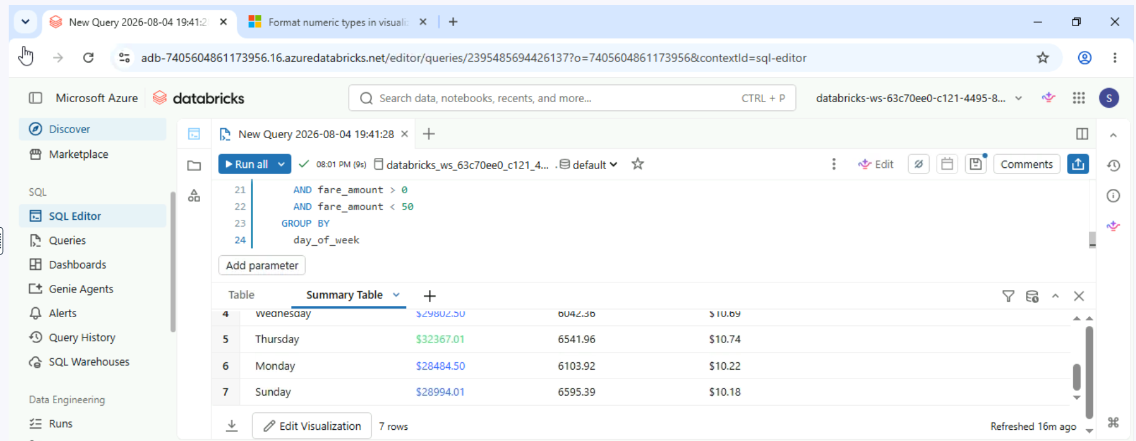

Customize your data analysis table
In this exercise, you'll create a new Customizable Table to analyze NYC taxi trips. Building on your existing visualization skills, this task will challenge you to further refine your data analysis by designing a table that finds and organizes key information more effectively.
Imagine you’re working on optimizing how you present and interpret data. With this exercise, you can adjust and format your table to ensure that relevant insights are easily accessible. Whether it’s sorting data by fare amounts, trip distances, or other metrics, your table will help you uncover detailed trends and insights from the taxi trip data.

- In the SQL Editor, write and execute the following query. Remember to untick LIMIT 1000 in the Run button to ensure all data is loaded before executing the query.
- Create a Table visualization that includes information on day_of_week (not "weekday"), trip_distance, and fare_amount.
- Make the column day_of_week searchable.
- Name the visualization as "Info Table" and save it
- In the Table, display only the results for "Sunday" and sort them by fare_amount in descending order.
What is the trip_distance for the trip with the highest fare_amount on a Sunday? R:

SELECT
T.tpep_pickup_datetime,
T.tpep_dropoff_datetime,
T.fare_amount,
T.pickup_zip,
T.dropoff_zip,
T.trip_distance,
T.weekday,
CASE
WHEN T.weekday = 1 THEN 'Sunday'
WHEN T.weekday = 2 THEN 'Monday'
WHEN T.weekday = 3 THEN 'Tuesday'
WHEN T.weekday = 4 THEN 'Wednesday'
WHEN T.weekday = 5 THEN 'Thursday'
WHEN T.weekday = 6 THEN 'Friday'
WHEN T.weekday = 7 THEN 'Saturday'
ELSE 'N/A'
END AS day_of_week
FROM
(
SELECT
dayofweek(tpep_pickup_datetime) as weekday,
*
FROM
`samples`.`nyctaxi`.`trips`
WHERE
trip_distance > 0
AND trip_distance < 10
AND fare_amount > 0
AND fare_amount < 50
) T
ORDER BY
T.weekday

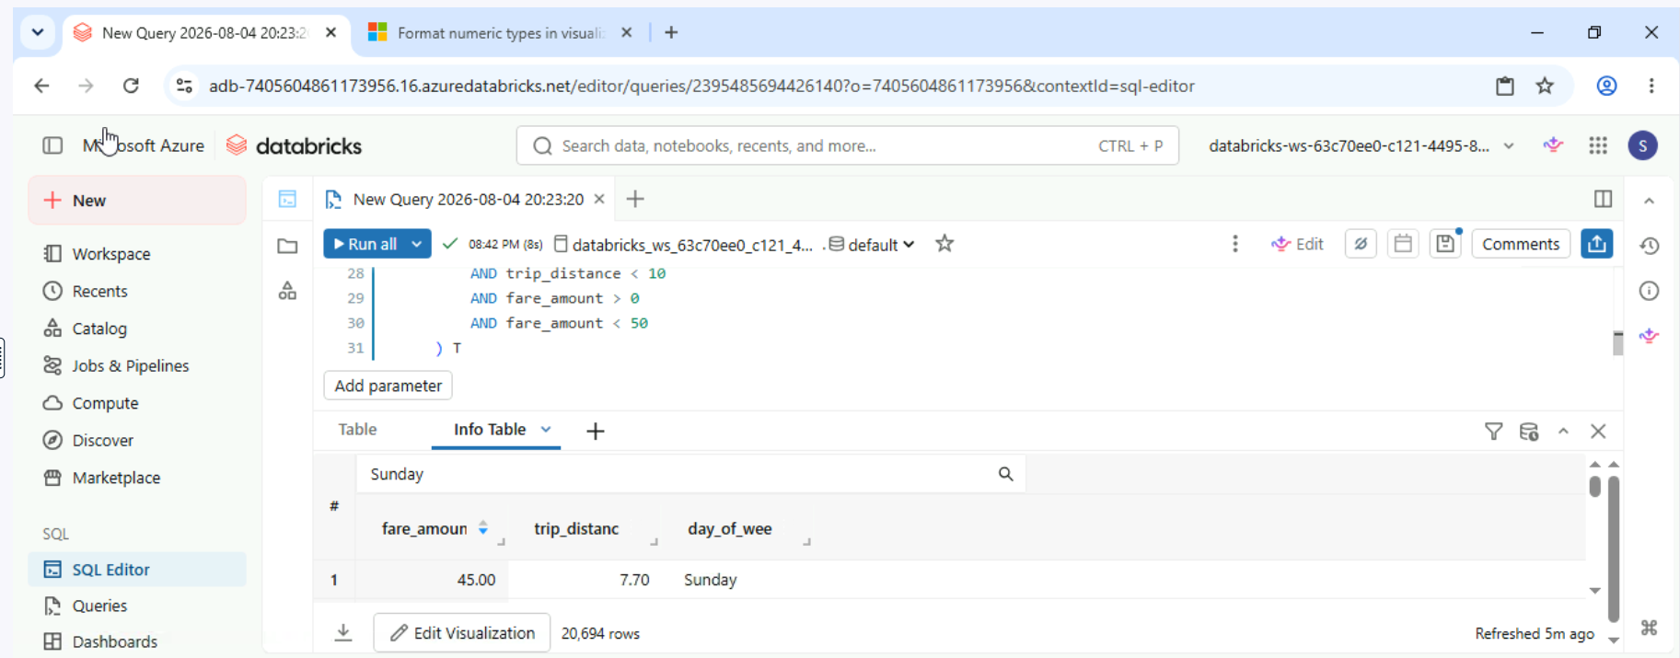

Chapter 3
Create a new dashboard by combining visualizations
Learning to create a Databricks dashboard is crucial as it equips you with the ability to visualize and interpret complex data efficiently.
Imagine you're a data analyst for a taxi company. Dashboards could help you track operations and uncover actionable insights that can enhance service and profitability. Let's get started and discover the stories the data can tell!
- In the SQL Editor, write and execute the following query. Remember to untick LIMIT 1000 in the Run button to ensure all data is loaded before executing the query.
- Create a Scatter plot visualization named "Daily Fare Trends" with trip_distance as the X column and fare_amount as the Y column.
- Create a Counter plot named "Total Trips" using Count rows as the value, which would count the total number of the trips.
- Select Save at the top right of the query tab. Add both visualizations to a new dashboard named "Trips".
- Change the dot color to red in the "Daily Fare Trends" widget in your dashboard.
- Replace the value "10" in the query condition "tripdistance < 10" with a parameter named "maxdistance". Assign the value "20" to the parameter "max_distance". Refresh the dashboard to apply the changes.
- What is the total trips count displayed on the dashboard? R:20,694

SELECT
T.tpep_pickup_datetime,
T.tpep_dropoff_datetime,
T.fare_amount,
T.pickup_zip,
T.dropoff_zip,
T.trip_distance,
T.weekday,
CASE
WHEN T.weekday = 1 THEN 'Sunday'
WHEN T.weekday = 2 THEN 'Monday'
WHEN T.weekday = 3 THEN 'Tuesday'
WHEN T.weekday = 4 THEN 'Wednesday'
WHEN T.weekday = 5 THEN 'Thursday'
WHEN T.weekday = 6 THEN 'Friday'
WHEN T.weekday = 7 THEN 'Saturday'
ELSE 'N/A'
END AS day_of_week
FROM
(
SELECT
dayofweek(tpep_pickup_datetime) as weekday,
*
FROM
`samples`.`nyctaxi`.`trips`
WHERE
trip_distance > 0
AND trip_distance < 10
AND fare_amount > 0
AND fare_amount < 50
) T
ORDER BY
T.weekday

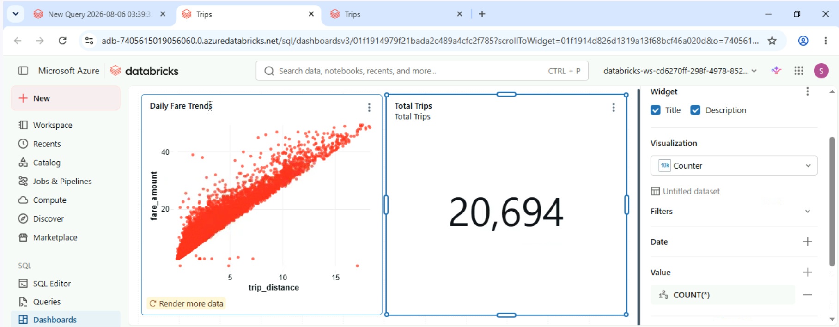

Add a new visualization to the dashboard
Databricks allows you to add visualizations directly to the existing dashboard without returning to the SQL Editor. Databricks also supports cross-filtering, enabling users to drill down into specific data points and explore relationships across multiple visualizations.
Your task is to add a new visualization that shows the total fares by weekday. This will help to understand ridership patterns and support informed decisions about resource allocation and promotional strategies.

Select Dashboards from the Sidebar. At the top right, select Create dashboard, then Import dashboard from file. Select Choose file from the pop up window.
Navigate to the Resources folder on the virtual desktop. Double-click on 3_1_exercise or select it then press OK. Select Import dashboard in the window to load it.
While in the dashboard, add a new empty visualization directly to the bottom of the existing layout.
Change the new added visualization to Bar. Choose day_of_week as the X axis, SUM(fare_amount) as the Y axis, and day_of_week as Color/Group by.
By using cross-filtering on the dashboard, what is the total trip count for Saturday? R:3,255

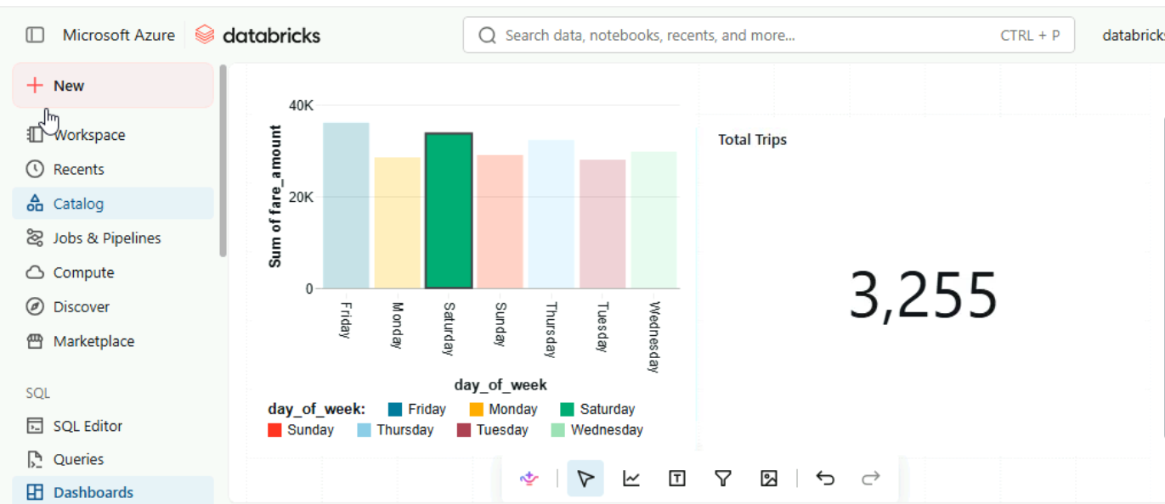

Edit the dashboard
Learning to edit Databricks dashboards is essential. Being proficient in tasks such as moving, resizing, adding, and deleting widgets allows you to tailor dashboards to your needs and preferences.
- Open and import 3_2_exercise as a dashboard.
- Remove the widgets "Total Trips" and "Route Revenue Attribution"
- Re-position the widget "Daily Fare Trends" to the bottom of the dashboard.
- Resize the widget "Daily Fare Trends" to fill the dashboard horizontally.
- Update the axis labels of "Daily Fare Trends" to display "Trip Distance (miles)" and "Fare Amount (USD)". R: 47

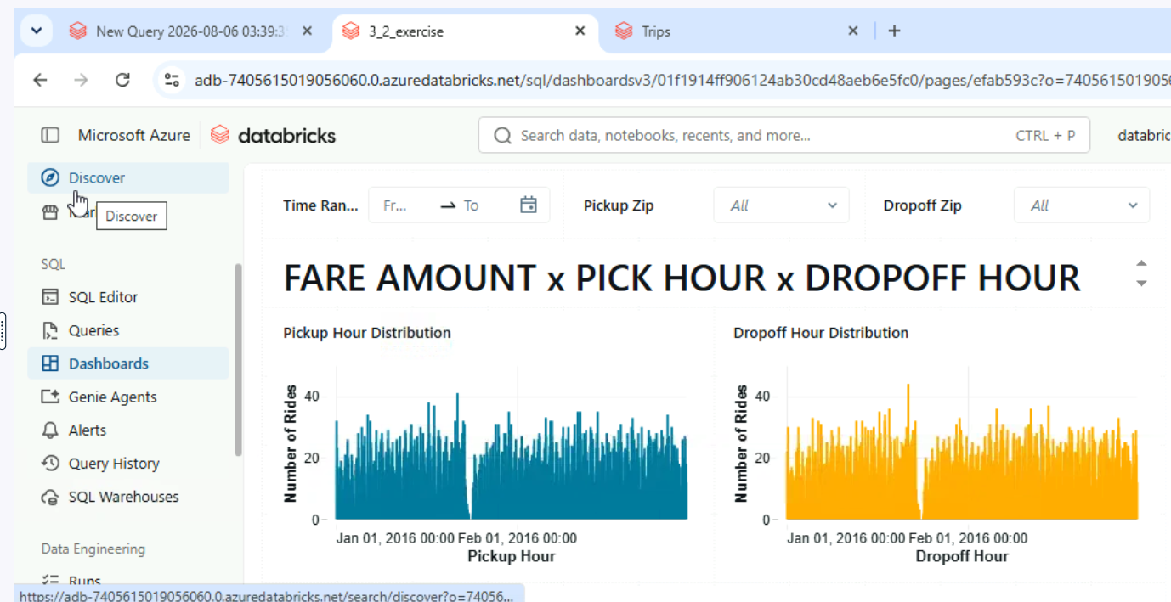
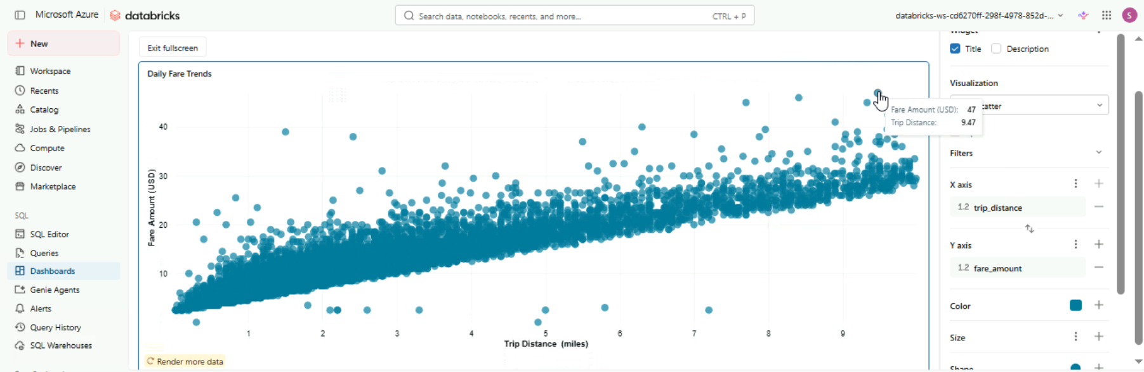

Refresh your dashboard
In this exercise, you will practice publishing your Databricks dashboard, making it accessible to your team members and stakeholders for collaborative analysis.
Once the dashboard is published, you will also explore how to refresh it, ensuring that the most current data is displayed.
Open and import 3_3_exercise as a dashboard.
Publish your dashboard with default settings.
Change your dashboard to published view.
Refresh your published dashboard Manually.
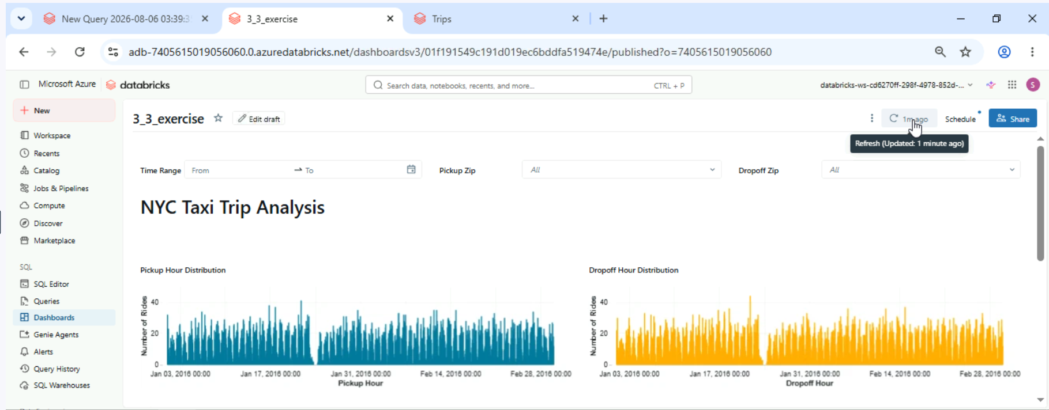
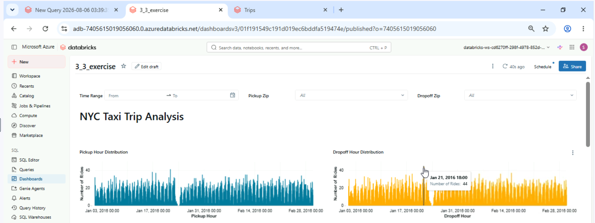

Create a schedule
Regularly scheduled refreshes help keep stakeholders informed with up-to-date insights and eliminate the need for manual updates.
In this exercise, you will learn how to schedule a refresh for your Databricks dashboard. By doing so, you can automate the process of updating your data visualizations, allowing team members and stakeholders to access the latest information without needing to refresh the dashboard manually.

- Open and import 3_4_exercise as a dashboard.
- Publish your dashboard with default settings.
- Change your dashboard to published view.
- Set up a scheduled refresh to occur daily at 9 PM UTC.
- Edit the newly added refresh and set it to 5 AM UTC.
- How many routes have a total revenue of zero? R: 4

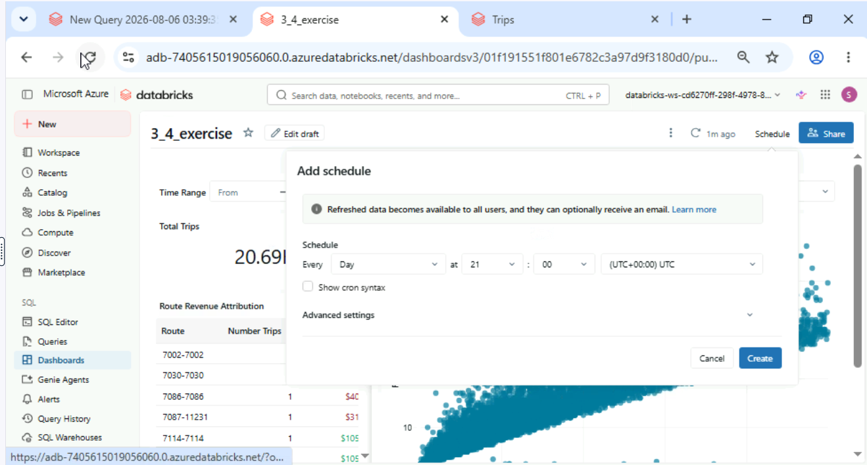
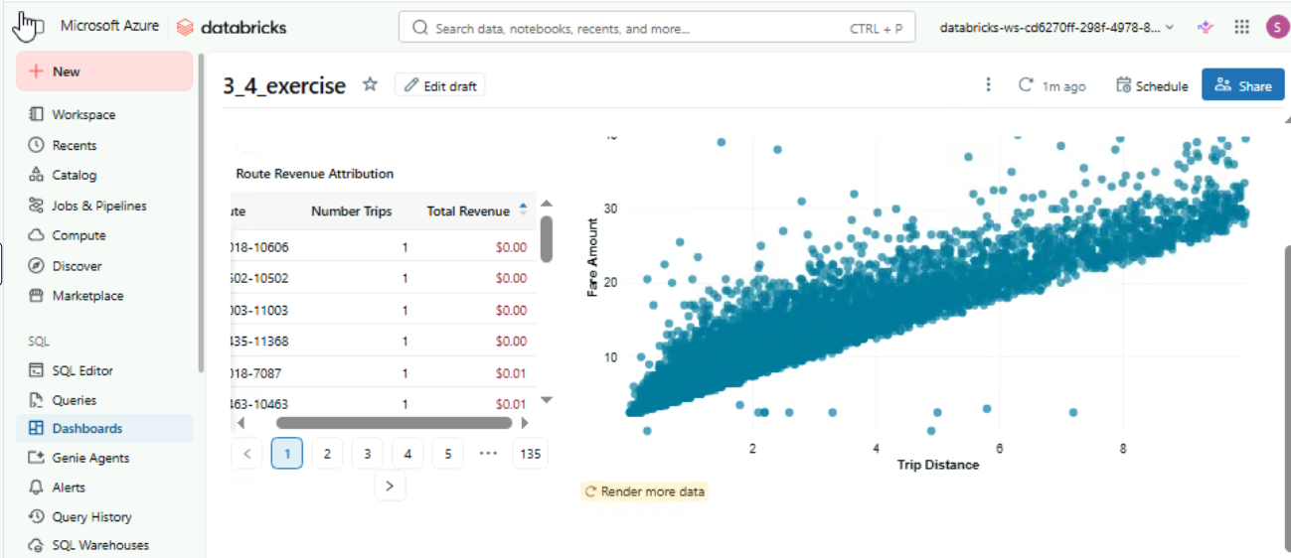

Configuring Widgets for dashboards
In this exercise you will configure Widgets to filter data and update visuals interactively. Adjusting settings like date ranges and locations will help users customize their dashboards and explore data more effectively. By the end, you'll have a dynamic, user-friendly dashboard that adapts to different needs in Databricks.

Open and import 3_5_exercise as a dashboard.
Add a new Widget to the dashboard that allows you to select the day_of_week.
Show only the results for "Monday" with the pickup zip code "10007" in the dashboard.
What is the corresponding fare amount for the longest trip distance? R:

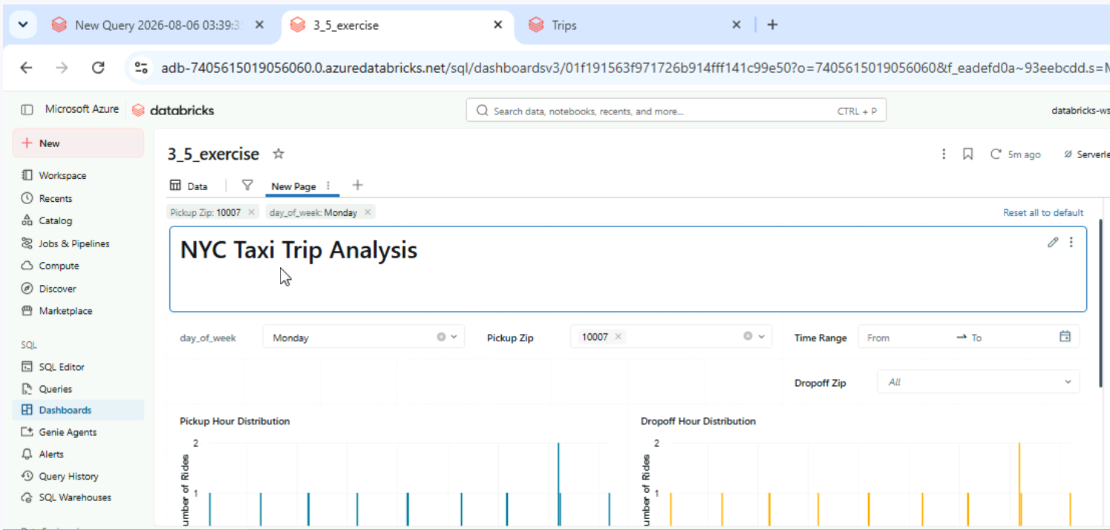
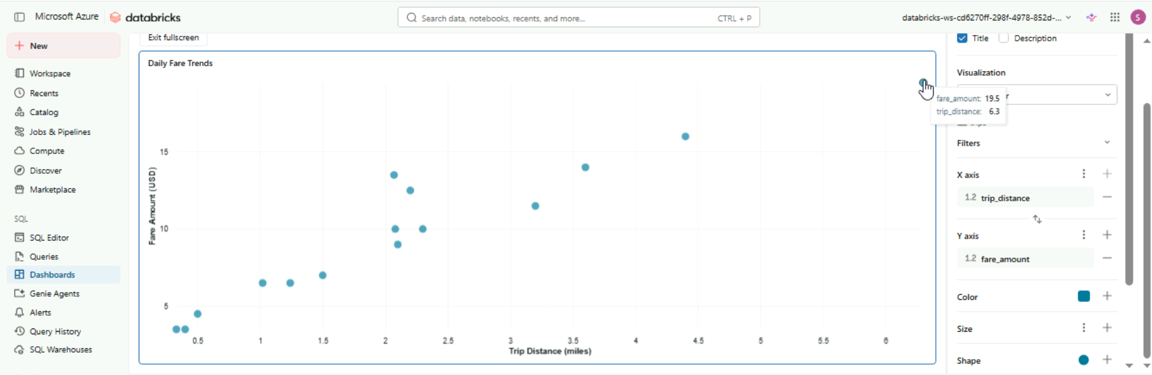

Chapter 4. Dashboard management
Clone your dashboard
You are a data analyst at a transportation company managing taxi fleet performance in New York City. Your team has created a dashboard that tracks key metrics like total trips, average fares, and trip durations. Now, the marketing department requests a customized version focused on long-distance trips. Instead of modifying the original dashboard, you’ll clone it, allowing you to tailor the new version without affecting the one your team relies on.
- Open and import 4_1_exercise as a dashboard.
- Create a clone dashboard named as "NYC Taxi Performance - Marketing"
- In your cloned dashboard, update the data to focus on long-distance trips by applying the condition: "tripdistance > 10", "fareamount > 0", and "fare_amount < 100".
- What is the total trips count displayed on the dashboard? R: 1,118

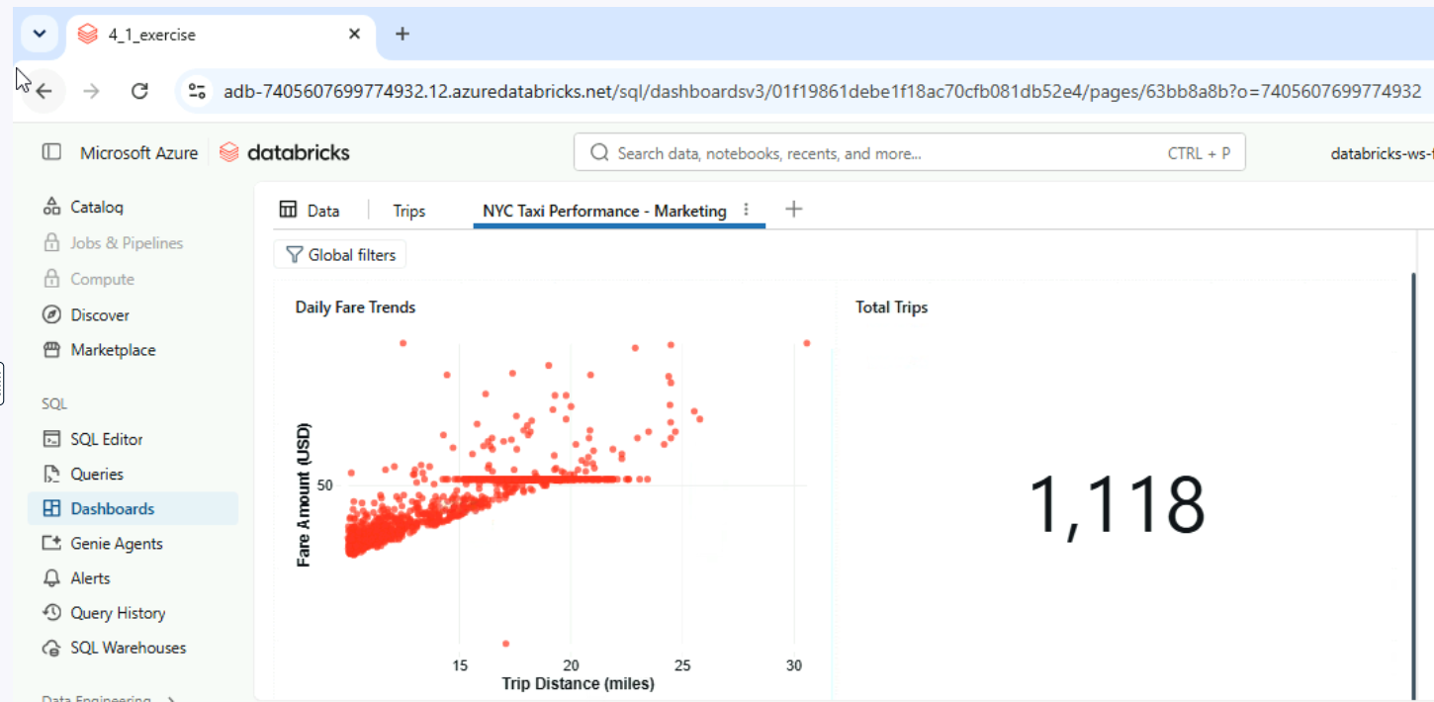

Export your dashboard
You’ve successfully created and customized a dashboard that tracks long-distance taxi trips for the marketing department. Now, you need to share this valuable information with your team members and stakeholders who may not have access to your Databricks workspace. Exporting the dashboard allows you to create a file that can be easily shared or stored for future reference.
- Open and import 4_1_exercise as a dashboard.
- Ensure that your dashboard is in the draft view so that you can export it.
- Export your dashboard named as "NYC Taxi Performance - Long-Distance Trips"
- What format is the exported dashboard saved in? R: JSON

Delete your dashboard
As a data analyst for a transportation company, you've been working on various dashboards to track performance metrics. Over time, some dashboards may become outdated or unnecessary. It's essential to manage your workspace by deleting dashboards that are no longer needed. In this exercise, you will delete a dashboard that was created for a marketing campaign that has since concluded.
- Open and import 4_1_exercise as a dashboard.
- Ensure that your dashboard is in the draft view so that you can export it.
- Move your dashboard to trash.
- Permanently delete your dashboard file from the trash.
- What steps should you take if you accidentally move a dashboard to the trash? R: Go to the ‘Trash’ section to restore it.

Sharing dashboards within the workspace
You work as a data analyst for a busy taxi company, where your primary responsibility is to analyze and interpret data to drive strategic decisions. In this fast-paced environment, you and your team heavily rely on dashboards in Databricks to monitor essential key metrics. These metrics include trip volumes, which help you understand demand patterns and optimize driver allocations, revenue figures that provide insights into overall profitability, and customer satisfaction scores that gauge the quality of service provided.
Your team collaborates closely to ensure that the dashboards are always updated with the latest data, allowing for real-time analysis and prompt decision-making. Each day, you review the dashboard to identify trends and patterns, such as peak hours for rides and customer feedback trends. This information is crucial for making data-driven recommendations to improve operational efficiency and enhance customer experience.

- Open and import the dashboard 4_2_exercise.
- Share the dashboard all workspace users and grant them “can view” permission.
- Share the dashboard with users with names starting with "student-11" and grant them “can edit” permission.
- Share the dashboard with "Admins" and grant them “can manage” permission.
- Some team members report they cannot access the dashboard. What steps can you take to troubleshoot and ensure that the dashboard is accessible to all team members with the appropriate permissions? Consider the following options: 1. Check Permissions: Verify that you assigned the correct permission levels (View, Edit, Manage) to each team member. 2. Folder Permissions: Ensure that the folder containing the dashboard has the necessary permissions that allow team members to access it. 3. Notification: Send a reminder to team members to refresh their view of the dashboard and check for any updates. 4. Contact Admin: If the issue persists, contact your Databricks administrator to check if there are any account-wide access issues. R: 1, 2 y 4.

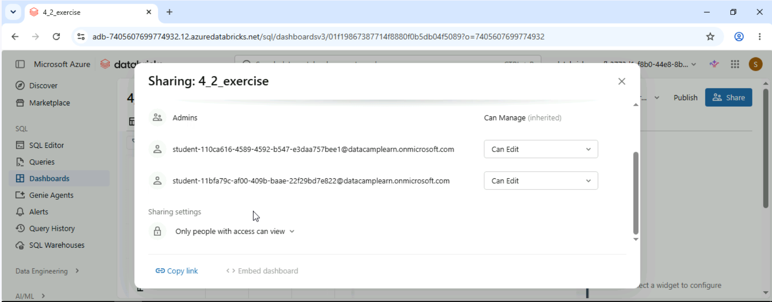

Sharing dashboards with account members
You work as a data analyst at a taxi company focused on improving operations and customer satisfaction. You’ve created a dashboard that displays key performance metrics.
Your manager, Sarah, has asked you to share this dashboard with two team members who is in your Databricks account.
- Open and import the dashboard 4_3_exercise.
- Publish your dashboard with default settings.
- Share your dashboard with all users in your Databricks account.
- If you change the dashboard in the draft view but do not republish it again, would other users in your Databricks account notice the change? R: No, users will only see the changes after the dashboard is republished.

Customize Alerts
In this exercise, you will create a new Alert with customized Notifications to keep track of important changes in your data.
You’ll start by defining the conditions that will trigger the Alert, then you will customize the Alert message to provide clear and actionable information.
The aim is to be able to set up Alerts that keep you informed of critical changes in your data. This will ensure timely responses to potential issues or significant trends, leading to better decision-making and more effective management of your data insights.

- In the SQL Editor, write the following query. Remember to untick LIMIT 1000 in the Run button to ensure all data is loaded before executing the query. Save the query as 4_4_exercise.
- Click Alerts in the Sidebar. Create a new alert named "low fare warning" for the query 4_4_exercise.
- In the Trigger Condition section, Select fare_amount as the Value column. Choose min as the aggregation type, set the Operator to <, and enter "0.01" as the Threshold value.
- Select the Template section and choose Use custom template. Set the notification subject as "Alert - extreme low fare found!". Select "Create alert".
- Set the Alert to run every day.
- Run the Alert manually once and wait for the outcome.
- Will the alert be triggered soon? R: Yes.
SELECT
*,
hour(tpep_pickup_datetime) as pickup_hour,
month(tpep_pickup_datetime) as month
FROM
`samples`.`nyctaxi`.`trips`

